CST 326 – Game Development

Project 4 - Tower Defense Part 1

California State University Monterey Bay

Objective:

This week we are going to work on the first part of our tower defense game.

SUBMISSION: FORMAT AND RULES

(Part 1) You have until Sunday, 11:59:30 PM to upload your solution for Project 4a. “Uploading” consists of sending the URL for your Git repository (if it’s public you don’t have to add me).

(Part 2) Upload the link from your screen captured video (should be an ‘unlisted’ video in YouTube in your profile) with you explaining your code (should be <5 minutes).

The total value of this activity: 40 bonus points

Implement the following in your game:

(5 Points) Create an initial map that the enemies will be traveling on to get to your tower

* Draw a battlefield (as an image) and put it as a sprite in the environment to help you with your level design

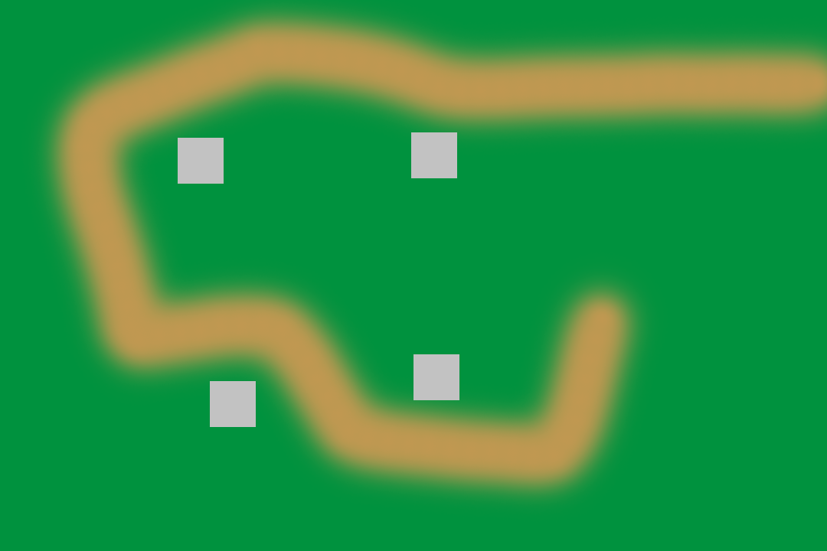

(5 Points) Drop waypoint gameobject along the “path” of the image in the scene.

* Waypoint 0 - Spawn Point
* Last Waypoint - Tower

(5 Points) Purse

* Add a script that will keep track of coins earned from killing enemies

(10 Points) Enemy

* (Behavior) travel along waypoints to Tower
* Have heath that can decrement and when health < 0, enemy is destroyed
* Add coins to “Purse” when enemy is destroyed

(5 Points) Implement Raycast to test destroying enemies

* Use mouse to test ‘clicking’ on enemies to reduce heath
* Have to click on the enemy several times (to reduce health to point the enemy is destroyed)

(10 Points) Create YouTube video to discuss Code